**OR GATE DATAFLOW MODEL**

**VHD code**

entity OR_GATE is

Port ( A : in STD_LOGIC;

B : in STD_LOGIC;

C : out STD_LOGIC);

end OR_GATE;

architecture DATAFLOW of OR_GATE is

begin

C<= A OR B;

end DATAFLOW;

**SCHEMEATIC DIAGRAM**

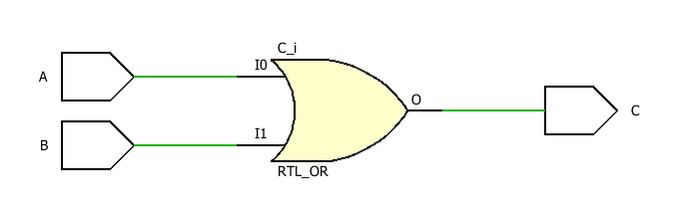

**TBW Code**

entity or_gate_flow is

-- Port ( );

end or_gate_flow;

architecture DATAFLOW of or_gate_flow is

component OR_GATE is

Port( A: in STD_LOGIC;

B: in STD_LOGIC;

C: out STD_LOGIC);

end component;

Signal A1:STD_LOGIC:='0';

Signal B1:STD_LOGIC:='0';

Signal C1:STD_LOGIC;

begin

UUT:OR_GATE port map(A=>A1, B=>B1, C=>C1);

Stim_proc:process

begin

wait for 100ns;

A1<='0';B1<='0';

wait for 100ns;

A1<='0';B1<='1';

wait for 100ns;

A1<='1';B1<='0';

wait for 100ns;

A1<='1';B1<='1';

wait;

end process;

end DATAFLOW;

**TBW Waveform**

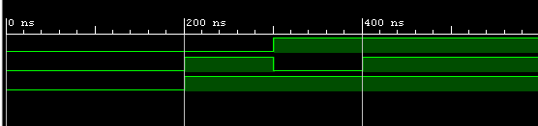

**NOT GATE DATAFLOW MODEL**

**VHD code**

entity NOT_GATE is

Port ( A : in STD_LOGIC;

B : out STD_LOGIC);

end NOT_GATE;

architecture DATAFLOW of NOT_GATE is

begin

B<= NOT A;

end DATAFLOW;

**SCHEMEATIC DIAGRAM**

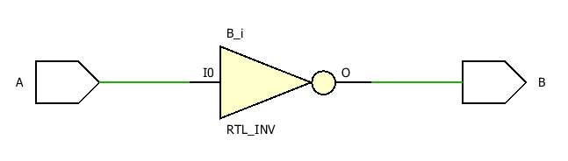

**TBW Code**

entity not_gate_flow is

-- Port ( );

end not_gate_flow;

architecture DATAFLOW of not_gate_flow is

component NOT_GATE is

Port( A: in STD_LOGIC;

B: out STD_LOGIC);

end component;

Signal A1:STD_LOGIC:='0';

Signal B1:STD_LOGIC;

begin

UUT:NOT_GATE port map(A=>A1, B=>B1);

Stim_proc:process

begin

wait for 100ns;

A1<='0';

wait for 100ns;

A1<='1';

wait;

end process;

end DATAFLOW;

**TBW Waveform**

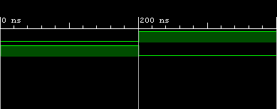

**NAND GATE DATAFLOW MODEL**

**VHD code**

entity NAND_GATE is

Port ( A : in STD_LOGIC;

B : in STD_LOGIC;

C : out STD_LOGIC);

end NAND_GATE;

architecture DATAFLOW of NAND_GATE is

begin

c<=NOT( A AND B);

end DATAFLOW;

**SCHEMEATIC DIAGRAM**

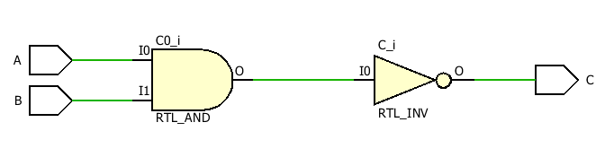

**TBW Code**

entity nand_gate_flow is

-- Port ( );

end nand_gate_flow;

architecture DATAFLOW of nand_gate_flow is

component NAND_GATE is

Port( A: in STD_LOGIC;

B: in STD_LOGIC;

C: out STD_LOGIC);

end component;

Signal A1:STD_LOGIC:='0';

Signal B1:STD_LOGIC:='0';

Signal C1:STD_LOGIC;

begin

UUT:NAND_GATE port map(A=>A1, B=>B1, C=>C1);

Stim_proc:process

begin

wait for 100ns;

A1<='0';B1<='0';

wait for 100ns;

A1<='0';B1<='1';

wait for 100ns;

A1<='1';B1<='0';

wait for 100ns;

A1<='1';B1<='1';

wait;

end process;

end DATAFLOW;

**TBW Waveform**

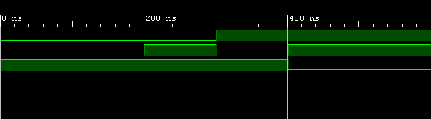

**NOR GATE DATAFLOW MODEL**

**VHD code**

entity NOR_GATE is

Port ( A : in STD_LOGIC;

B : in STD_LOGIC;

C : out STD_LOGIC);

end NOR_GATE;

architecture DATAFLOW of NOR_GATE is

begin

C<= NOT(A OR B);

end DATAFLOW;

**SCHEMEATIC DIAGRAM**

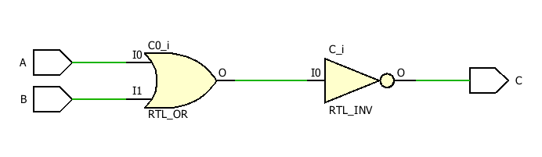

**TBW Code**

entity nor_gate_flow is

-- Port ( );

end nor _gate_flow;

architecture DATAFLOW of nor_gate_flow is

component NOR_GATE is

Port( A: in STD_LOGIC;

B: in STD_LOGIC;

C: out STD_LOGIC);

end component;

Signal A1:STD_LOGIC:='0';

Signal B1:STD_LOGIC:='0';

Signal C1:STD_LOGIC;

begin

UUT:NOR_GATE port map(A=>A1, B=>B1, C=>C1);

Stim_proc:process

begin

wait for 100ns;

A1<='0';B1<='0';

wait for 100ns;

A1<='0';B1<='1';

wait for 100ns;

A1<='1';B1<='0';

wait for 100ns;

A1<='1';B1<='1';

wait;

end process;

end DATAFLOW;

**TBW Waveform**

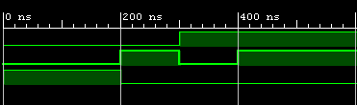

**AND GATE DATAFLOW MODEL**

**VHD code**

entity AND_GATE is

Port ( A : in STD_LOGIC;

B : in STD_LOGIC;

C : out STD_LOGIC);

end AND_GATE;

architecture DATAFLOW of AND_GATE is

begin

C<= A AND B;

end DATAFLOW;

**SCHEMEATIC DIAGRAM**

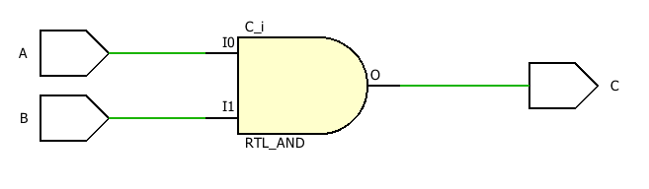

**TBW Code**

entity and_gate_flow is

-- Port ( );

end and_gate_flow;

architecture DATAFLOW of and_gate_flow is

component AND_GATE is

Port( A: in STD_LOGIC;

B: in STD_LOGIC;

C: out STD_LOGIC);

end component;

Signal A1:STD_LOGIC:='0';

Signal B1:STD_LOGIC:='0';

Signal C1:STD_LOGIC;

begin

UUT:AND_GATE port map(A=>A1, B=>B1, C=>C1);

Stim_proc:process

begin

wait for 100ns;

A1<='0';B1<='0';

wait for 100ns;

A1<='0';B1<='1';

wait for 100ns;

A1<='1';B1<='0';

wait for 100ns;

A1<='1';B1<='1';

wait;

end process;

end DATAFLOW;

**TBW Waveform**

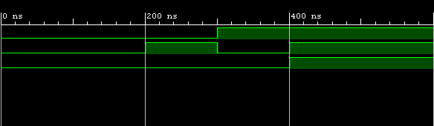

**XOR GATE DATAFLOW MODEL**

**VHD code**

entity XOR_GATE is

Port ( A : in STD_LOGIC;

B : in STD_LOGIC;

C : out STD_LOGIC);

end XOR_GATE;

architecture DATAFLOW of XOR_GATE is

begin

C<= A XOR B;

end DATAFLOW;

**SCHEMEATIC DIAGRAM**

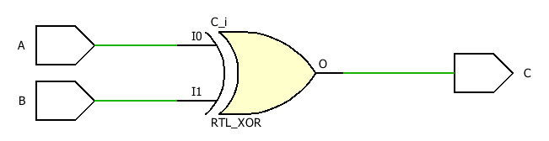

**TBW Code**

entity xor_gate_flow is

-- Port ( );

end xor_gate_flow;

architecture DATAFLOW of xor_gate_flow is

component XOR_GATE is

Port( A: in STD_LOGIC;

B: in STD_LOGIC;

C: out STD_LOGIC);

end component;

Signal A1:STD_LOGIC:='0';

Signal B1:STD_LOGIC:='0';

Signal C1:STD_LOGIC;

begin

UUT:XOR_GATE port map(A=>A1, B=>B1, C=>C1);

Stim_proc:process

begin

wait for 100ns;

A1<='0';B1<='0';

wait for 100ns;

A1<='0';B1<='1';

wait for 100ns;

A1<='1';B1<='0';

wait for 100ns;

A1<='1';B1<='1';

wait;

end process;

end DATAFLOW;

**TBW Waveform**

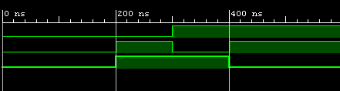

**XNOR GATE DATAFLOW MODEL**

**VHD code**

entity XNOR_GATE is

Port ( A : in STD_LOGIC;

B : in STD_LOGIC;

C : out STD_LOGIC);

end XNOR_GATE;

architecture DATAFLOW of XNOR_GATE is

begin

C<= A XNOR B;

end DATAFLOW;

**SCHEMEATIC DIAGRAM**

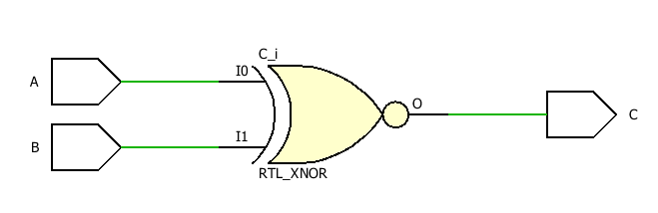

**TBW Code**

entity xnor_gate_flow is

-- Port ( );

end xnor_gate_flow;

architecture DATAFLOW of xnor_gate_flow is

component XNOR_GATE is

Port( A: in STD_LOGIC;

B: in STD_LOGIC;

C: out STD_LOGIC);

end component;

Signal A1:STD_LOGIC:='0';

Signal B1:STD_LOGIC:='0';

Signal C1:STD_LOGIC;

begin

UUT:XNOR_GATE port map(A=>A1, B=>B1, C=>C1);

Stim_proc:process

begin

wait for 100ns;

A1<='0';B1<='0';

wait for 100ns;

A1<='0';B1<='1';

wait for 100ns;

A1<='1';B1<='0';

wait for 100ns;

A1<='1';B1<='1';

wait;

end process;

end DATAFLOW;

**TBW Waveform**

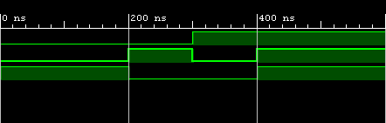

**AND GATE FORM NAND GATE DATAFLOW MODEL**

**VHD code**

entity NAND_AND is

Port ( A : in STD_LOGIC;

B : in STD_LOGIC;

C : out STD_LOGIC);

end NAND_AND;

architecture Behavioral of NAND_AND is

begin

C<= (A NAND B) NAND (A NAND B);

end Behavioral;

**SCHEMEATIC DIAGRAM**

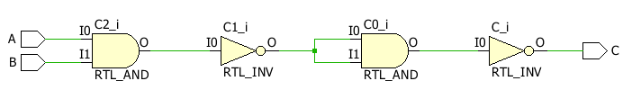

**TBW Code**

entity nand_and_gate_flow is

-- Port ( );

end nand_and_gate_flow;

architecture DATAFLOW of nand_and_gate_flow is

component NAND_AND is

Port( A: in STD_LOGIC;

B: in STD_LOGIC;

C: out STD_LOGIC);

end component;

Signal A1:STD_LOGIC:='0';

Signal B1:STD_LOGIC:='0';

Signal C1:STD_LOGIC;

begin

UUT:NAND_AND port map(A=>A1, B=>B1, C=>C1);

Stim_proc:process

begin

wait for 100ns;

A1<='0';B1<='0';

wait for 100ns;

A1<='0';B1<='1';

wait for 100ns;

A1<='1';B1<='0';

wait for 100ns;

A1<='1';B1<='1';

wait;

end process;

end DATAFLOW;

**TBW Waveform**

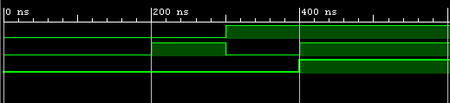

**OR GATE FORM NAND GATE DATAFLOW MODEL**

**VHD code**

entity NAND_OR is

Port ( A : in STD_LOGIC;

B : in STD_LOGIC;

C : out STD_LOGIC);

end NAND_OR;

architecture Behavioral of NAND_OR is

begin

C<= (A NAND A) NAND (B NAND B);

end Behavioral;

**SCHEMEATIC DIAGRAM**

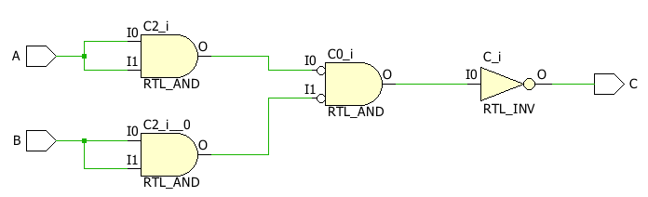

**TBW Code**

entity nand_or_gate_flow is

-- Port ( );

end nand_or_gate_flow;

architecture DATAFLOW of nand_or_gate_flow is

component NAND_OR is

Port( A: in STD_LOGIC;

B: in STD_LOGIC;

C: out STD_LOGIC);

end component;

Signal A1:STD_LOGIC:='0';

Signal B1:STD_LOGIC:='0';

Signal C1:STD_LOGIC;

begin

UUT:NAND_OR port map(A=>A1, B=>B1, C=>C1);

Stim_proc:process

begin

wait for 100ns;

A1<='0';B1<='0';

wait for 100ns;

A1<='0';B1<='1';

wait for 100ns;

A1<='1';B1<='0';

wait for 100ns;

A1<='1';B1<='1';

wait;

end process;

end DATAFLOW;

**TBW Waveform**

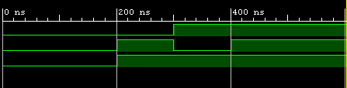

**NOT GATE FORM NAND GATE DATAFLOW MODEL**

**VHD code**

entity NAND_NOT is

Port ( A : in STD_LOGIC;

C : out STD_LOGIC);

end NAND_NOT;

architecture DATAFLOW of NAND_NOT is

begin

C<= A NAND A;

end DATAFLOW;

**SCHEMEATIC DIAGRAM**

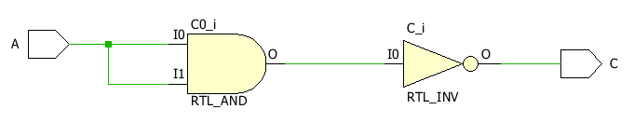

**TBW Code**

entity nand_not_gate_flow is

-- Port ( );

end nand_not_gate_flow;

architecture DATAFLOW of nand_not_gate_flow is

component NAND_NOT is

Port( A: in STD_LOGIC;

C: out STD_LOGIC);

end component;

Signal A1:STD_LOGIC:='0';

Signal C1:STD_LOGIC;

begin

UUT:NAND_NOT port map(A=>A1,C=>C1);

Stim_proc:process

begin

wait for 100ns;

A1<='0';

wait for 100ns;

A1<='1';

wait;

end process;

end DATAFLOW;

**TBW Waveform**

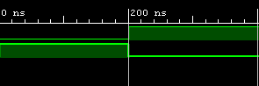

**XOR GATE FORM NAND GATE DATAFLOW MODEL**

**VHD code**

entity NAND_XOR is

Port ( A : in STD_LOGIC;

B : in STD_LOGIC;

C : out STD_LOGIC);

end NAND_XOR;

architecture DATAFLOW of NAND_XOR is

begin

C<= ((A NAND A) NAND B) NAND ((B NAND B) NAND A);

end DATAFLOW;

**SCHEMEATIC DIAGRAM**

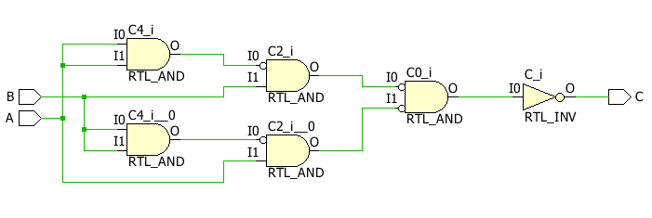

**TBW Code**

entity nand_xor_gate_flow is

-- Port ( );

end nand_xor_gate_flow;

architecture DATAFLOW of nand_xor_gate_flow is

component NAND_XOR is

Port( A: in STD_LOGIC;

B: in STD_LOGIC;

C: out STD_LOGIC);

end component;

Signal A1:STD_LOGIC:='0';

Signal B1:STD_LOGIC:='0';

Signal C1:STD_LOGIC;

begin

UUT:NAND_XOR port map(A=>A1, B=>B1, C=>C1);

Stim_proc:process

begin

wait for 100ns;

A1<='0';B1<='0';

wait for 100ns;

A1<='0';B1<='1';

wait for 100ns;

A1<='1';B1<='0';

wait for 100ns;

A1<='1';B1<='1';

wait;

end process;

end DATAFLOW;

**TBW Waveform**

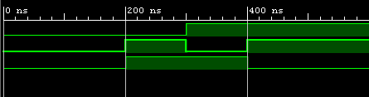

**XNOR GATE FORM NAND GATE DATAFLOW MODEL**

**VHD code**

entity NAND_XNOR is

Port ( A : in STD_LOGIC;

B : in STD_LOGIC;

C : out STD_LOGIC);

end NAND_XNOR;

architecture DATAFLOW of NAND_XNOR is

begin

C<= (A NAND B) NAND ((A NAND A) NAND (B NAND B));

end DATAFLOW;

**SCHEMEATIC DIAGRAM**

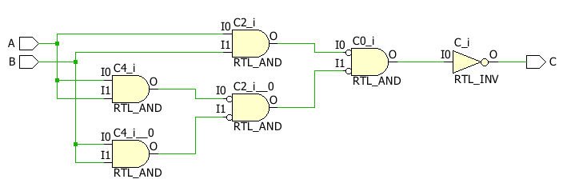

**TBW Code**

entity nand_xnor_gate_flow is

-- Port ( );

end nand_xnor_gate_flow;

architecture DATAFLOW of nand_xnor_gate_flow is

component NAND_XNOR is

Port( A: in STD_LOGIC;

B: in STD_LOGIC;

C: out STD_LOGIC);

end component;

Signal A1:STD_LOGIC:='0';

Signal B1:STD_LOGIC:='0';

Signal C1:STD_LOGIC;

begin

UUT:NAND_XNOR port map(A=>A1, B=>B1, C=>C1);

Stim_proc:process

begin

wait for 100ns;

A1<='0';B1<='0';

wait for 100ns;

A1<='0';B1<='1';

wait for 100ns;

A1<='1';B1<='0';

wait for 100ns;

A1<='1';B1<='1';

wait;

end process;

end DATAFLOW;

**TBW Waveform**

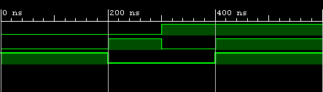

**NOT GATE FORM NOR GATE DATAFLOW MODEL**

**VHD code**

entity NOR_NOT is

Port ( A : in STD_LOGIC;

C : out STD_LOGIC);

end NOR_NOT;

architecture DATAFLOW of NOR_NOT is

begin

C<= A NOR A;

end DATAFLOW;

**SCHEMEATIC DIAGRAM**

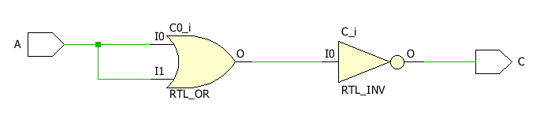

**TBW Code**

entity nor_not_gate_flow is

-- Port ( );

end nor_not_gate_flow;

architecture DATAFLOW of nor_not_gate_flow is

component NOR_NOT is

Port( A: in STD_LOGIC;

C: out STD_LOGIC);

end component;

Signal A1:STD_LOGIC:='0';

Signal C1:STD_LOGIC;

begin

UUT:NOR_NOT port map(A=>A1,C=>C1);

Stim_proc:process

begin

wait for 100ns;

A1<='0';

wait for 100ns;

A1<='1';

wait;

end process;

end DATAFLOW;

**TBW Waveform**

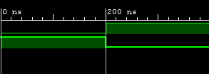

**OR GATE FORM NOR GATE DATAFLOW MODEL**

**VHD code**

entity NOR_OR is

Port ( A : in STD_LOGIC;

B : in STD_LOGIC;

C : out STD_LOGIC);

end NOR_OR;

architecture DATAFLOW of NOR_OR is

begin

C<= (A NOR B) NOR (A NOR B);

end DATAFLOW;

**SCHEMEATIC DIAGRAM**

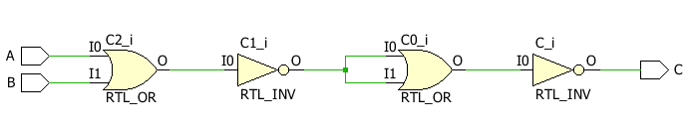

**TBW Code**

entity nor_or_gate_flow is

-- Port ( );

end nor_or_gate_flow;

architecture DATAFLOW of nor_or_gate_flow is

component NOR_OR is

Port( A: in STD_LOGIC;

B: in STD_LOGIC;

C: out STD_LOGIC);

end component;

Signal A1:STD_LOGIC:='0';

Signal B1:STD_LOGIC:='0';

Signal C1:STD_LOGIC;

begin

UUT:NOR_OR port map(A=>A1, B=>B1, C=>C1);

Stim_proc:process

begin

wait for 100ns;

A1<='0';B1<='0';

wait for 100ns;

A1<='0';B1<='1';

wait for 100ns;

A1<='1';B1<='0';

wait for 100ns;

A1<='1';B1<='1';

wait;

end process;

end DATAFLOW;

**TBW Waveform**



**AND GATE FORM NOR GATE DATAFLOW MODEL**

**VHD code**

entity NOR_AND is

Port ( A : in STD_LOGIC;

B : in STD_LOGIC;

C : out STD_LOGIC);

end NOR_AND;

architecture DATAFLOW of NOR_AND is

begin

C<= (A NOR A) NOR (B NOR B);

end DATAFLOW;

**SCHEMEATIC DIAGRAM**

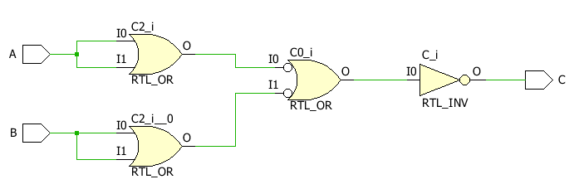

**TBW Code**

entity nor_and_gate_flow is

-- Port ( );

end nor_and_gate_flow;

architecture DATAFLOW of nor_and_gate_flow is

component NOR_AND is

Port( A: in STD_LOGIC;

B: in STD_LOGIC;

C: out STD_LOGIC);

end component;

Signal A1:STD_LOGIC:='0';

Signal B1:STD_LOGIC:='0';

Signal C1:STD_LOGIC;

begin

UUT:NOR_AND port map(A=>A1, B=>B1, C=>C1);

Stim_proc:process

begin

wait for 100ns;

A1<='0';B1<='0';

wait for 100ns;

A1<='0';B1<='1';

wait for 100ns;

A1<='1';B1<='0';

wait for 100ns;

A1<='1';B1<='1';

wait;

end process;

end DATAFLOW;

**TBW Waveform**

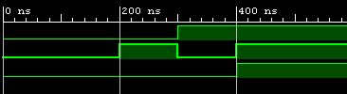

**XOR GATE FORM NOR GATE DATAFLOW MODEL**

**VHD code**

entity NOR_XOR is

Port ( A : in STD_LOGIC;

B : in STD_LOGIC;

C : out STD_LOGIC);

end NOR_XOR;

architecture DATAFLOW of NOR_XOR is

begin

C<= (A NOR B) NOR ( (A NOR A) NOR (B NOR B) );

end DATAFLOW;

**SCHEMEATIC DIAGRAM**

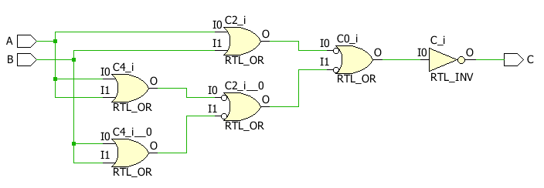

**TBW Code**

entity nor_xor_gate_flow is

-- Port ( );

end nor_xor_gate_flow;

architecture DATAFLOW of nor_xor_gate_flow is

component NOR_XOR is

Port( A: in STD_LOGIC;

B: in STD_LOGIC;

C: out STD_LOGIC);

end component;

Signal A1:STD_LOGIC:='0';

Signal B1:STD_LOGIC:='0';

Signal C1:STD_LOGIC;

begin

UUT:NOR_XOR port map(A=>A1, B=>B1, C=>C1);

Stim_proc:process

begin

wait for 100ns;

A1<='0';B1<='0';

wait for 100ns;

A1<='0';B1<='1';

wait for 100ns;

A1<='1';B1<='0';

wait for 100ns;

A1<='1';B1<='1';

wait;

end process;

end DATAFLOW;

**TBW Waveform**

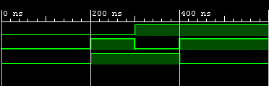

**XNOR GATE FORM NOR GATE DATAFLOW MODEL**

**VHD code**

entity NOR_XNOR is

Port ( A : in STD_LOGIC;

B : in STD_LOGIC;

C : out STD_LOGIC);

end NOR_XNOR;

architecture DATAFLOW of NOR_XNOR is

begin

C<= (A NOR (A NOR B)) NOR (B NOR (A NOR B));

end DATAFLOW;

**SCHEMEATIC DIAGRAM**

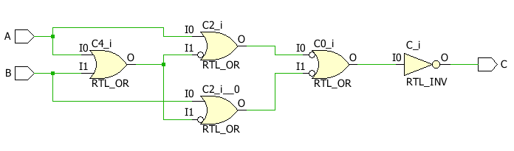

**TBW Code**

entity nor_xnor_gate_flow is

-- Port ( );

end nor_xnor_gate_flow;

architecture DATAFLOW of nor_xnor_gate_flow is

component NOR_XNOR is

Port( A: in STD_LOGIC;

B: in STD_LOGIC;

C: out STD_LOGIC);

end component;

Signal A1:STD_LOGIC:='0';

Signal B1:STD_LOGIC:='0';

Signal C1:STD_LOGIC;

begin

UUT:NOR_XNOR port map(A=>A1, B=>B1, C=>C1);

Stim_proc:process

begin

wait for 100ns;

A1<='0';B1<='0';

wait for 100ns;

A1<='0';B1<='1';

wait for 100ns;

A1<='1';B1<='0';

wait for 100ns;

A1<='1';B1<='1';

wait;

end process;

end DATAFLOW;

**TBW Waveform**



**OR GATE BEHAVIORAL MODEL**

**VHD code**

entity OR_GATE is

Port ( A : in STD_LOGIC;

B : in STD_LOGIC;

C : out STD_LOGIC);

end OR_GATE;

architecture Behavioral of OR_GATE is

begin

process(A,B)

begin

if(A ='1' or B='1') then

C<='1';

else

C<='0';

end if;

end process;

end Behavioral;

**SCHEMEATIC DIAGRAM**



**TBW Code**

entity or_gate_flow is

-- Port ( );

end or_gate_flow;

architecture Behavioral of or_gate_flow is

component OR_GATE is

Port( A: in STD_LOGIC;

B: in STD_LOGIC;

C: out STD_LOGIC);

end component;

Signal A1:STD_LOGIC:='0';

Signal B1:STD_LOGIC:='0';

Signal C1:STD_LOGIC;

begin

UUT:OR_GATE port map(A=>A1, B=>B1, C=>C1);

Stim_proc:process

begin

wait for 100ns;

A1<='0';B1<='0';

wait for 100ns;

A1<='0';B1<='1';

wait for 100ns;

A1<='1';B1<='0';

wait for 100ns;

A1<='1';B1<='1';

wait;

end process;

end Behavioral;

**TBW Waveform**



**NOT GATE BEHAVIORAL MODEL**

**VHD code**

entity NOT_GATE is

Port ( A : in STD_LOGIC;

B : out STD_LOGIC);

end NOT_GATE;

architecture Behavioral of NOT_GATE is

begin

process(A)

begin

if(A ='0') then

B<='1';

else

B<='0';

end if;

end process;

end Behavioral;

**SCHEMEATIC DIAGRAM**

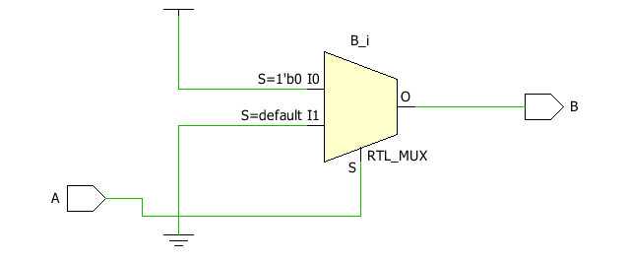

**TBW Code**

entity not_gate_flow is

-- Port ( );

end not_gate_flow;

architecture Behavioral of not_gate_flow is

component NOT_GATE is

Port( A: in STD_LOGIC;

B: out STD_LOGIC);

end component;

Signal A1:STD_LOGIC:='0';

Signal B1:STD_LOGIC;

begin

UUT:NOT_GATE port map(A=>A1, B=>B1);

Stim_proc:process

begin

wait for 100ns;

A1<='0';

wait for 100ns;

A1<='1';

wait;

end process;

end Behavioral;

**TBW Waveform**



**NAND GATE BEHAVIORAL MODEL**

**VHD code**

entity NAND_GATE is

Port ( A : in STD_LOGIC;

B : in STD_LOGIC;

C : out STD_LOGIC);

end NAND_GATE;

architecture Behavioral of NAND_GATE is

begin

process(A,B)

begin

if(A ='1' and B='1') then

C<='0';

else

C<='1';

end if;

end process;

end Behavioral;

**SCHEMEATIC DIAGRAM**

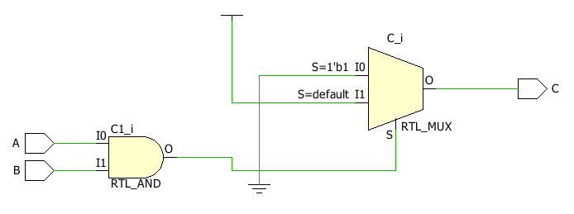

**TBW Code**

entity nand_gate_flow is

-- Port ( );

end nand_gate_flow;

architecture Behavioral of nand_gate_flow is

component NAND_GATE is

Port( A: in STD_LOGIC;

B: in STD_LOGIC;

C: out STD_LOGIC);

end component;

Signal A1:STD_LOGIC:='0';

Signal B1:STD_LOGIC:='0';

Signal C1:STD_LOGIC;

begin

UUT:NAND_GATE port map(A=>A1, B=>B1, C=>C1);

Stim_proc:process

begin

wait for 100ns;

A1<='0';B1<='0';

wait for 100ns;

A1<='0';B1<='1';

wait for 100ns;

A1<='1';B1<='0';

wait for 100ns;

A1<='1';B1<='1';

wait;

end process;

end Behavioral;

**TBW Waveform**



**NOR GATE BEHAVIORAL MODEL**

**VHD code**

entity NOR_GATE is

Port ( A : in STD_LOGIC;

B : in STD_LOGIC;

C : out STD_LOGIC);

end NOR_GATE;

architecture Behavioral of NOR_GATE is

begin

process(A,B)

begin

if(A ='0' and B='0') then

C<='1';

else

C<='0';

end if;

end process;

end Behavioral;

**SCHEMEATIC DIAGRAM**

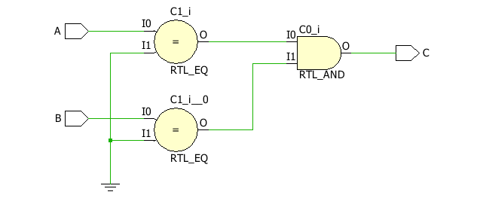

**TBW Code**

entity nor_gate_flow is

-- Port ( );

end nor_gate_flow;

architecture Behavioral of nor_gate_flow is

component NOR_GATE is

Port( A: in STD_LOGIC;

B: in STD_LOGIC;

C: out STD_LOGIC);

end component;

Signal A1:STD_LOGIC:='0';

Signal B1:STD_LOGIC:='0';

Signal C1:STD_LOGIC;

begin

UUT:NOR_GATE port map(A=>A1, B=>B1, C=>C1);

Stim_proc:process

begin

wait for 100ns;

A1<='0';B1<='0';

wait for 100ns;

A1<='0';B1<='1';

wait for 100ns;

A1<='1';B1<='0';

wait for 100ns;

A1<='1';B1<='1';

wait;

end process;

end Behavioral;

**TBW Waveform**



**AND GATE BEHAVIORAL MODEL**

**VHD code**

entity AND_GATE is

Port ( A : in STD_LOGIC;

B : in STD_LOGIC;

C : out STD_LOGIC);

end AND_GATE;

architecture Behavioral of AND_GATE is

begin

process(A,B)

begin

if(A ='0' or B='0') then

C<='0';

else

C<='1';

end if;

end process;

end Behavioral;

**SCHEMEATIC DIAGRAM**

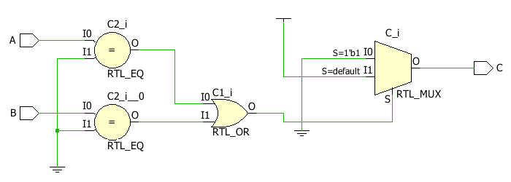

**TBW Code**

entity and_gate_flow is

-- Port ( );

end and_gate_flow;

architecture Behavioral of and_gate_flow is

component AND_GATE is

Port( A: in STD_LOGIC;

B: in STD_LOGIC;

C: out STD_LOGIC);

end component;

Signal A1:STD_LOGIC:='0';

Signal B1:STD_LOGIC:='0';

Signal C1:STD_LOGIC;

begin

UUT:AND_GATE port map(A=>A1, B=>B1, C=>C1);

Stim_proc:process

begin

wait for 100ns;

A1<='0';B1<='0';

wait for 100ns;

A1<='0';B1<='1';

wait for 100ns;

A1<='1';B1<='0';

wait for 100ns;

A1<='1';B1<='1';

wait;

end process;

end Behavioral;

**TBW Waveform**



**XOR GATE BEHAVIORAL MODEL**

**VHD code**

entity XOR_GATE is

Port ( A : in STD_LOGIC;

B : in STD_LOGIC;

C : out STD_LOGIC);

end XOR_GATE;

architecture Behavioral of XOR_GATE is

begin

process(A,B)

begin

if(A = B) then

C<='0';

else

C<='1';

end if;

end process;

end Behavioral;

**SCHEMEATIC DIAGRAM**

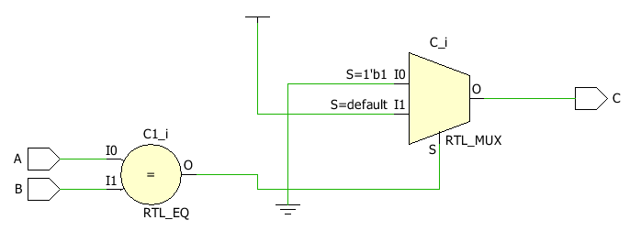

**TBW Code**

entity nor_gate_flow is

-- Port ( );

end nor_gate_flow;

architecture Behavioral of nor_gate_flow is

component XOR_GATE is

Port( A: in STD_LOGIC;

B: in STD_LOGIC;

C: out STD_LOGIC);

end component;

Signal A1:STD_LOGIC:='0';

Signal B1:STD_LOGIC:='0';

Signal C1:STD_LOGIC;

begin

UUT:XOR_GATE port map(A=>A1, B=>B1, C=>C1);

Stim_proc:process

begin

wait for 100ns;

A1<='0';B1<='0';

wait for 100ns;

A1<='0';B1<='1';

wait for 100ns;

A1<='1';B1<='0';

wait for 100ns;

A1<='1';B1<='1';

wait;

end process;

end Behavioral;

**TBW Waveform**



**XNOR GATE BEHAVIORAL MODEL**

**VHD code**

entity XNOR_GATE is

Port ( A : in STD_LOGIC;

B : in STD_LOGIC;

C : out STD_LOGIC);

end XNOR_GATE;

architecture Behavioralof XNOR_GATE is

begin

process(A,B)

begin

if(A = B) then

C<='1';

else

C<='0';

end if;

end process;

end Behavioral;

**SCHEMEATIC DIAGRAM**

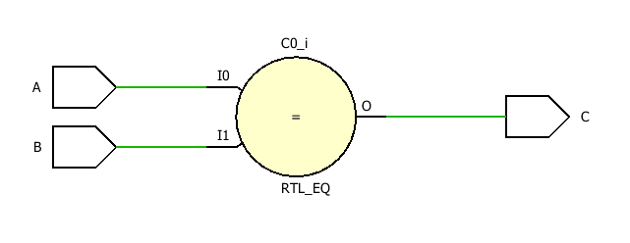

**TBW Code**

entity xnor_gate_flow is

-- Port ( );

end xnor_gate_flow;

architecture Behavioral of xnor_gate_flow is

component XNOR_GATE is

Port( A: in STD_LOGIC;

B: in STD_LOGIC;

C: out STD_LOGIC);

end component;

Signal A1:STD_LOGIC:='0';

Signal B1:STD_LOGIC:='0';

Signal C1:STD_LOGIC;

begin

UUT:XNOR_GATE port map(A=>A1, B=>B1, C=>C1);

Stim_proc:process

begin

wait for 100ns;

A1<='0';B1<='0';

wait for 100ns;

A1<='0';B1<='1';

wait for 100ns;

A1<='1';B1<='0';

wait for 100ns;

A1<='1';B1<='1';

wait;

end process;

end Behavioral;

**TBW Waveform**



**HALF ADDER DATAFLOW MODEL**

**VHD code**

entity HALF_ADDER is

Port ( A : in STD_LOGIC;

B : in STD_LOGIC;

S : out STD_LOGIC;

C : out STD_LOGIC);

end HALF_ADDER;

architecture DATAFLOW of HALF_ADDER is

begin

S<= A XOR B;

C<= A AND B;

end DATAFLOW;

**SCHEMEATIC DIAGRAM**

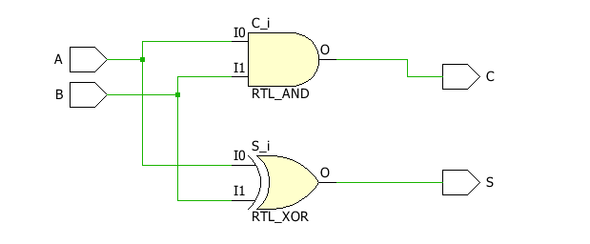

**TBW Code**

entity half_adder_gate_flow is

-- Port ( );

end half_adder_gate_flow;

architecture DATAFLOW of half_adder_gate_flow is

component HALF_ADDER is

Port( A: in STD_LOGIC;

B: in STD_LOGIC;

S: out STD_LOGIC;

C: out STD_LOGIC);

end component;

Signal A1:STD_LOGIC:='0';

Signal B1:STD_LOGIC:='0';

Signal S1:STD_LOGIC;

Signal C1:STD_LOGIC;

begin

UUT:HALF_ADDER port map(A=>A1, B=>B1, S=>S1, C=>C1);

Stim_proc:process

begin

wait for 100ns;

A1<='0';B1<='0';

wait for 100ns;

A1<='0';B1<='1';

wait for 100ns;

A1<='1';B1<='0';

wait for 100ns;

A1<='1';B1<='1';

wait;

end process;

end DATAFLOW;

**TBW Waveform**

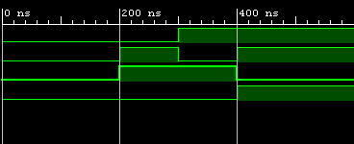

**HALF ADDER BEHAVIORAL MODEL**

**VHD code**

entity HALF_ADDER is

Port ( A : in STD_LOGIC;

B : in STD_LOGIC;

S : out STD_LOGIC;

C : out STD_LOGIC);

end HALF_ADDER;

architecture Behavioral of HALF_ADDER is

begin

process(A,B)

begin

if(A = B) then

S<='0';

else

S<='1';

end if;

if(A='1' and B='1') then

C<='1';

else

C<='0';

end if;

end process;

end Behavioral;

**SCHEMEATIC DIAGRAM**

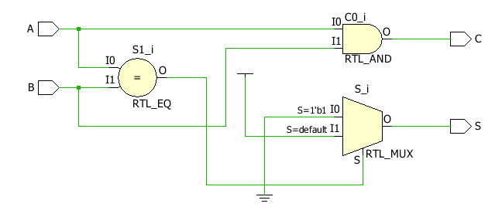

**TBW Code**

entity half_adder_gate_flow is

-- Port ( );

end half_adder_gate_flow;

architecture Behavioral of half_adder_gate_flow is

component HALF_ADDER is

Port( A: in STD_LOGIC;

B: in STD_LOGIC;

S: out STD_LOGIC;

C: out STD_LOGIC);

end component;

Signal A1:STD_LOGIC:='0';

Signal B1:STD_LOGIC:='0';

Signal S1:STD_LOGIC;

Signal C1:STD_LOGIC;

begin

UUT:HALF_ADDER port map(A=>A1, B=>B1, S=>S1, C=>C1);

Stim_proc:process

begin

wait for 100ns;

A1<='0';B1<='0';

wait for 100ns;

A1<='0';B1<='1';

wait for 100ns;

A1<='1';B1<='0';

wait for 100ns;

A1<='1';B1<='1';

wait;

end process;

end Behavioral;

**TBW Waveform**



**FULL ADDER DATAFLOW MODEL**

**VHD code**

entity FULL_ADDER is

Port ( A : in STD_LOGIC;

B : in STD_LOGIC;

C : in STD_LOGIC;

S : out STD_LOGIC;

Cout : out STD_LOGIC);

end FULL_ADDER;

architecture DATAFLOW of FULL_ADDER is

begin

S<= (A XOR B) XOR C;

Cout<= (A AND B) OR (C AND B) OR (A AND C);

end DATAFLOW;

**SCHEMEATIC DIAGRAM**

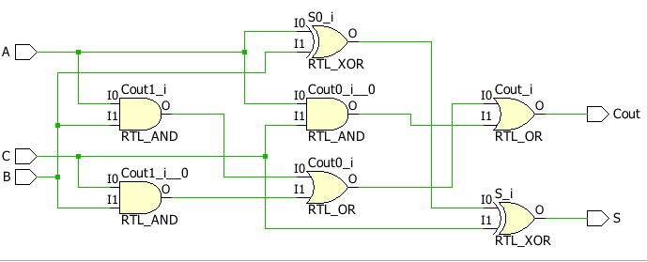

**TBW Code**

entity full_adder_gate_flow is

-- Port ( );

end full_adder_gate_flow;

architecture DATAFLOW of full_adder_gate_flow is

component FULL_ADDER is

Port( A: in STD_LOGIC;

B: in STD_LOGIC;

C: in STD_LOGIC;

S: out STD_LOGIC;

Cout: out STD_LOGIC);

end component;

Signal A1:STD_LOGIC:='0';

Signal B1:STD_LOGIC:='0';

Signal C1:STD_LOGIC:='0';

Signal S1:STD_LOGIC;

Signal Cout1:STD_LOGIC;

begin

UUT:FULL_ADDER port map(A=>A1, B=>B1, S=>S1, C=>C1, Cout=> Cout1);

Stim_proc:process

begin

wait for 100ns;

C1<='0';A1<='0';B1<='0';

wait for 100ns;

C1<='0';A1<='0';B1<='1';

wait for 100ns;

C1<='0';A1<='1';B1<='0';

wait for 100ns;

C1<='0';A1<='1';B1<='1';

wait for 100ns;

C1<='1';A1<='0';B1<='0';

wait for 100ns;

C1<='1';A1<='0';B1<='1';

wait for 100ns;

C1<='1';A1<='1';B1<='0';

wait for 100ns;

C1<='1';A1<='1';B1<='1';

wait;

end process;

end DATAFLOW;

**TBW Waveform**

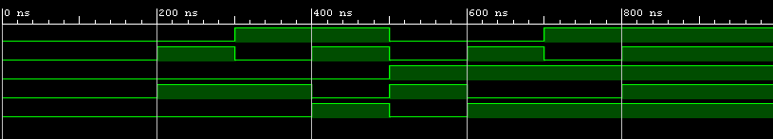

**FULL ADDER BEHAVIORAL MODEL**

**VHD code**

entity FULL_ADDER is

Port ( A : in STD_LOGIC;

B : in STD_LOGIC;

C : in STD_LOGIC;

S : out STD_LOGIC;

Cout : out STD_LOGIC);

end FULL_ADDER;

architecture Behavioral of FULL_ADDER is

begin

process(A,B,C)

begin

if(A='0')then

if(B=C)then

S<='0';

else

S<='1';

end if;

else

if(B=C)then

S<='1';

else

S<='0';

end if;

end if;

if(A='0')then

if(B='1' and C='1')then

Cout<='1';

else

Cout<='0';

end if;

else

if(B='0' and C='0')then

Cout<='0';

else

Cout<='1';

end if;

end if;

end process;

end Behavioral;

**SCHEMEATIC DIAGRAM**

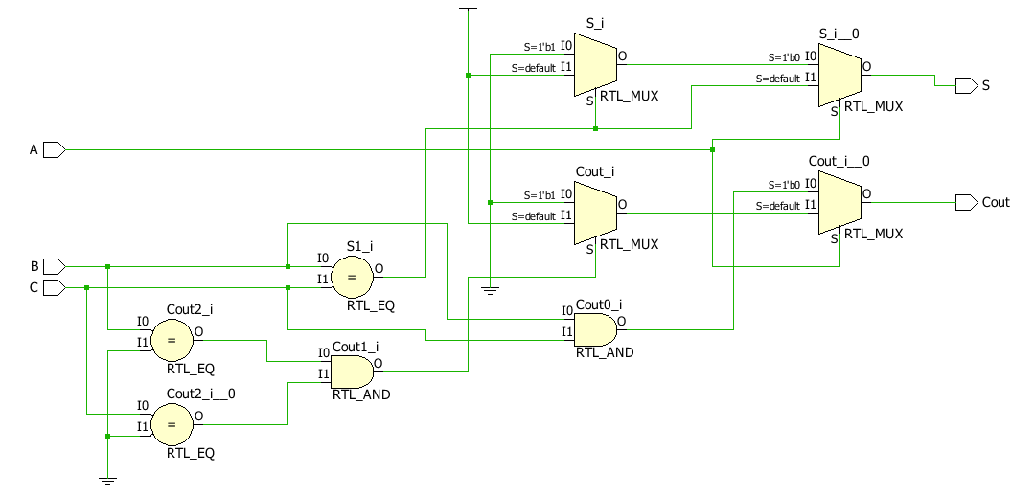

**TBW Code**

entity full_adder_gate_flow is

-- Port ( );

end full_adder_gate_flow;

architecture Behavioral of full_adder_gate_flow is

component FULL_ADDER is

Port( A: in STD_LOGIC;

B: in STD_LOGIC;

C: in STD_LOGIC;

S: out STD_LOGIC;

Cout: out STD_LOGIC);

end component;

Signal A1:STD_LOGIC:='0';

Signal B1:STD_LOGIC:='0';

Signal C1:STD_LOGIC:='0';

Signal S1:STD_LOGIC;

Signal Cout1:STD_LOGIC;

begin

UUT:FULL_ADDER port map(A=>A1, B=>B1, S=>S1, C=>C1, Cout=> Cout1);

Stim_proc:process

begin

wait for 100ns;

C1<='0';A1<='0';B1<='0';

wait for 100ns;

C1<='0';A1<='0';B1<='1';

wait for 100ns;

C1<='0';A1<='1';B1<='0';

wait for 100ns;

C1<='0';A1<='1';B1<='1';

wait for 100ns;

C1<='1';A1<='0';B1<='0';

wait for 100ns;

C1<='1';A1<='0';B1<='1';

wait for 100ns;

C1<='1';A1<='1';B1<='0';

wait for 100ns;

C1<='1';A1<='1';B1<='1';

wait;

end process;

end Behavioral;

**TBW Waveform**



**2:1 MUX DATAFLOW MODEL**

**VHD code**

entity MUX is

Port ( I0 : in STD_LOGIC;

I1 : in STD_LOGIC;

S : in STD_LOGIC;

O : out STD_LOGIC);

end MUX;

architecture DATAFLOW of MUX is

begin

O<=((NOT S)AND I0)OR (S AND I1);

end DATAFLOW;

**SCHEMEATIC DIAGRAM**

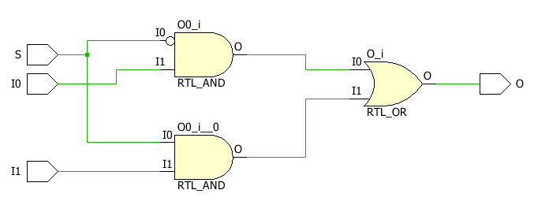

**TBW Code**

entity mux_gate_flow is

-- Port ( );

end mux_gate_flow;

architecture DATAFLOW of mux_gate_flow is

component MUX is

Port( I0: in STD_LOGIC;

I1: in STD_LOGIC;

S: in STD_LOGIC;

O: out STD_LOGIC);

end component;

Signal I01:STD_LOGIC:='0';

Signal I11:STD_LOGIC:='1';

Signal S1:STD_LOGIC:='0';

Signal O1:STD_LOGIC;

begin

UUT: MUX port map(I0=>I01,I1=>I11,S=>S1,O=>O1);

stim_proc: process

begin

wait for 100ns;

S1<='1';

wait;

end process;

end DATAFLOW;

**TBW Waveform**

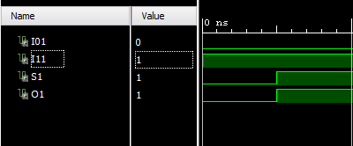

**2:1 MUX BEHAVIORAL MODEL**

**VHD code**

entity MUX is

Port ( S : in STD_LOGIC;

I0 : in STD_LOGIC;

I1 : in STD_LOGIC;

O : out STD_LOGIC);

end MUX;

architecture Behavioral of MUX is

begin

process (S,I0,I1)

begin

if(S='0')then

O<=I0;

else

O<=I1;

end if;

end process;

end Behavioral;

**SCHEMEATIC DIAGRAM**

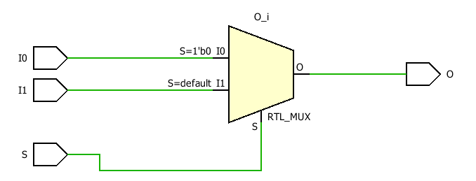

**TBW Code**

entity mux_gate_flow is

-- Port ( );

end mux_gate_flow;

architecture Behavioral of mux_gate_flow is

component MUX is

Port( I0: in STD_LOGIC;

I1: in STD_LOGIC;

S: in STD_LOGIC;

O: out STD_LOGIC);

end component;

Signal I01:STD_LOGIC:='0';

Signal I11:STD_LOGIC:='1';

Signal S1:STD_LOGIC:='0';

Signal O1:STD_LOGIC;

begin

UUT: MUX port map(I0=>I01,I1=>I11,S=>S1,O=>O1);

stim_proc: process

begin

wait for 100ns;

S1<='1';

wait;

end process;

end Behavioral;

**TBW Waveform**



**4:1 MUX DATAFLOW MODEL**

**VHD code**

entity MUX is

Port ( I : in STD_LOGIC_VECTOR (3 downto 0);

S : in STD_LOGIC_VECTOR (1 downto 0);

O : out STD_LOGIC);

end MUX;

architecture DATAFLOW of MUX is

begin

O<=I(0) when S="00"else

I(1) when S="01"else

I(2) when S="10"else

I(3);

end DATAFLOW;

**SCHEMEATIC DIAGRAM**

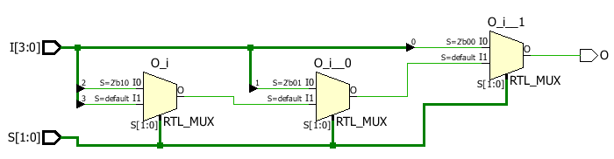

**TBW Code**

entity mux_gate_flow is

-- Port ( );

end mux_gate_flow;

architecture DATAFLOW of mux_gate_flow is

component MUX is

Port ( I : in STD_LOGIC_VECTOR (3 downto 0);

S : in STD_LOGIC_VECTOR (1 downto 0);

O : out STD_LOGIC);

end component;

signal I1: STD_LOGIC_VECTOR(3 downto 0):="0010";

signal S1: STD_LOGIC_VECTOR(1 downto 0):="00";

signal O1: STD_LOGIC;

begin

uut: MUX port map(I=>I1,S=>S1,O=>O1);

stim_proc: process

begin

wait for 100ns;

S1<="01";

wait for 100ns;

S1<="10";

wait for 100ns;

S1<="11";

end process;

end DATAFLOW;

**TBW Waveform**

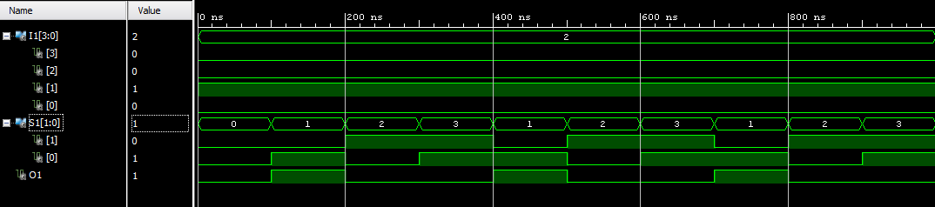

**4:1 MUX BEHAVIORAL MODEL**

**VHD code**

entity MUX is

Port ( I : in STD_LOGIC_VECTOR (3 downto 0);

S : in STD_LOGIC_VECTOR (1 downto 0);

O : out STD_LOGIC);

end MUX;

architecture Behavioral of MUX is

begin

process(I,S)

begin

case S is

when "00"=>O<=I(0);

when "01"=>O<=I(1);

when "10"=>O<=I(2);

when "11"=>O<=I(3);

when others=>NULL;

end case;

end process;

end Behavioral;

**SCHEMEATIC DIAGRAM**

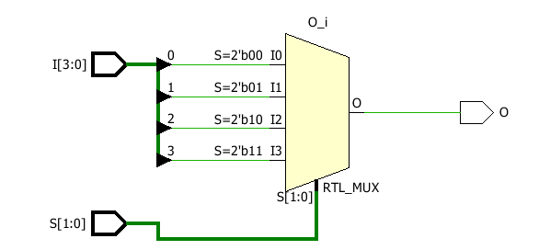

**TBW Code**

entity mux_gate_flow is

-- Port ( );

end mux_gate_flow;

architecture Behavioral of mux_gate_flow is

component MUX is

Port ( I : in STD_LOGIC_VECTOR (3 downto 0);

S : in STD_LOGIC_VECTOR (1 downto 0);

O : out STD_LOGIC);

end component;

signal I1: STD_LOGIC_VECTOR(3 downto 0):="0010";

signal S1: STD_LOGIC_VECTOR(1 downto 0):="00";

signal O1: STD_LOGIC;

begin

uut: MUX port map(I=>I1,S=>S1,O=>O1);

stim_proc: process

begin

wait for 100ns;

S1<="01";

wait for 100ns;

S1<="10";

wait for 100ns;

S1<="11";

end process;

end Behavioral;

**TBW Waveform**



**3:8 DECODER BEHAVIORAL MODEL**

**VHD code**

entity DECODE is

Port ( I : in STD_LOGIC_VECTOR (2 downto 0);

O : out STD_LOGIC_VECTOR (7 downto 0));

end DECODE;

architecture Behavioral of DECODE is

begin

process(I)

begin

O<="00000000";

case I is

when "000"=> O(0) <='1';

when "001"=> O(1) <='1';

when "010"=> O(2) <='1';

when "011"=> O(3) <='1';

when "100"=> O(4) <='1';

when "101"=>O(5)<='1';

when "110"=>O(6)<='1';

when "111"=>O(7)<='1';

when others=>NULL;

end case;

end process;

end Behavioral;

**SCHEMEATIC DIAGRAM**

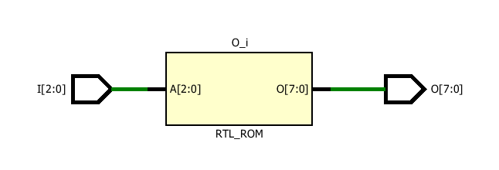

**TBW Code**

entity decode_gate_flow is

-- Port ( );

end decode_gate_flow;

architecture Behavioral of decode_gate_flow is

component DECODE is

Port ( I : in STD_LOGIC_VECTOR (2 downto 0);

O : out STD_LOGIC_VECTOR (7 downto 0));

end component;

signal I1: STD_LOGIC_VECTOR(2 downto 0):="000";

signal O1: STD_LOGIC_VECTOR(7 downto 0):="00000000";

begin

uut: DECODE port map(I=>I1,O=>O1);

stim_proc: process

begin

wait for 100ns;

I1<="001";

wait for 100ns;

I1<="010";

wait for 100ns;

I1<="011";

wait for 100ns;

I1<="100";

wait for 100ns;

I1<="101";

wait for 100ns;

I1<="110";

wait for 100ns;

I1<="111";

end process;

end Behavioral;

**TBW Waveform**

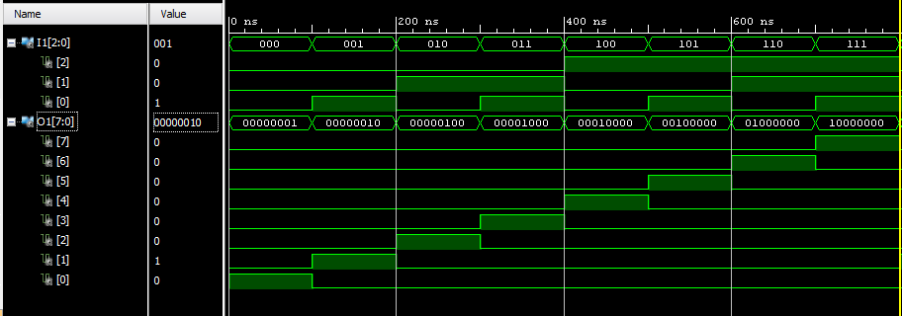

**3:8 DECODER DATAFLOW MODEL**

**VHD code**

entity DECODE is

Port ( I : in STD_LOGIC_VECTOR (2 downto 0);

O : out STD_LOGIC_VECTOR (7 downto 0));

end DECODE;

architecture DATAFLOW of DECODE is

begin

O(0)<= '1' WHEN I="000" ELSE '0';

O(1)<= '1' WHEN I="001" ELSE '0';

O(2)<= '1' WHEN I="010" ELSE '0';

O(3)<= '1' WHEN I="011" ELSE '0';

O(4)<= '1' WHEN I="100" ELSE '0';

O(5)<= '1' WHEN I="101" ELSE '0';

O(6)<= '1' WHEN I="110" ELSE '0';

O(7)<= '1' WHEN I="111" ELSE '0';

end DATAFLOW;

**SCHEMEATIC DIAGRAM**

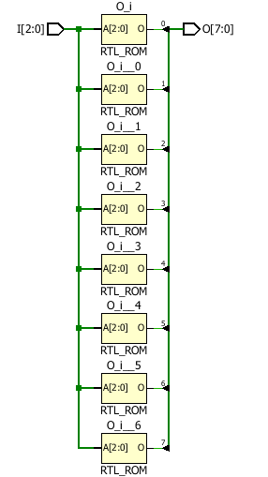

**TBW Code**

entity decode_gate_flow is

-- Port ( );

end decode_gate_flow;

architecture DATAFLOW of decode_gate_flow is

component DECODE is

Port ( I : in STD_LOGIC_VECTOR (2 downto 0);

O : out STD_LOGIC_VECTOR (7 downto 0));

end component;

signal I1: STD_LOGIC_VECTOR(2 downto 0):="000";

signal O1: STD_LOGIC_VECTOR(7 downto 0):="00000000";

begin

uut: DECODE port map(I=>I1,O=>O1);

stim_proc: process

begin

wait for 100ns;

I1<="001";

wait for 100ns;

I1<="010";

wait for 100ns;

I1<="011";

wait for 100ns;

I1<="100";

wait for 100ns;

I1<="101";

wait for 100ns;

I1<="110";

wait for 100ns;

I1<="111";

end process;

end DATAFLOW;

**TBW Waveform**



**FULL ADDER (STRUCTURAL MODEL)**

**VHD code**

entity FULL_ADDER_STR is

Port ( X : in STD_LOGIC;

Y : in STD_LOGIC;

Z : in STD_LOGIC;

Sum : out STD_LOGIC;

Carry : out STD_LOGIC);

end FULL_ADDER_STR;

architecture STRUCTURAL of FULL_ADDER_STR is

component HALF_ADDER is

Port ( A : in STD_LOGIC;

B : in STD_LOGIC;

S : out STD_LOGIC;

C : out STD_LOGIC);

end component;

component OR_GATE is

Port ( A : in STD_LOGIC;

B : in STD_LOGIC;

C : out STD_LOGIC);

end component;

signal S1:STD_LOGIC;

signal C1:STD_LOGIC;

signal C2:STD_LOGIC;

begin

L1: HALF_ADDER port map(X,Y,S1,C1);

L2: HALF_ADDER port map(S1,Z,Sum,C2);

L3: OR_GATE port map(C1,C2,Carry);

end STRUCTURAL;

**SCHEMEATIC DIAGRAM**

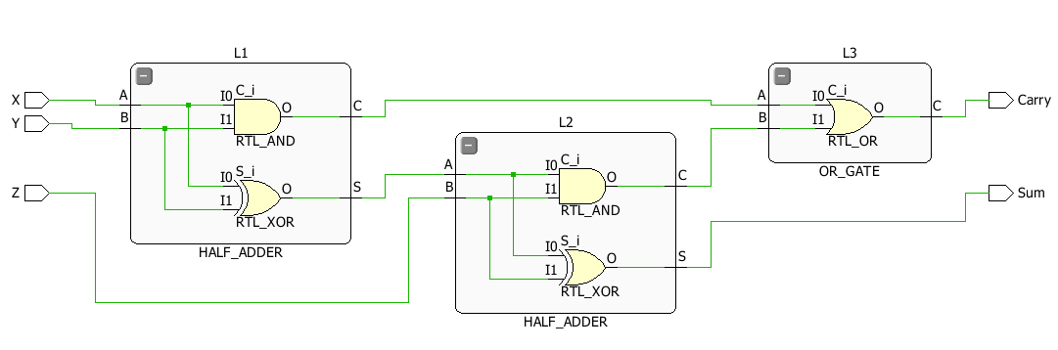

**TBW Code**

entity FULL_ADDER is

-- Port ( );

end FULL_ADDER;

architecture STRUCTURAL of FULL_ADDER is

component FULL_ADDER_STR is

Port ( X : in STD_LOGIC;

Y : in STD_LOGIC;

Z : in STD_LOGIC;

Sum : out STD_LOGIC;

Carry : out STD_LOGIC);

end component;

signal A1:STD_LOGIC:='0';

signal B1:STD_LOGIC:='0';

signal C1:STD_LOGIC:='0';

signal S1:STD_LOGIC;

signal CY1:STD_LOGIC;

begin

uut: FULL_ADDER_STR Port Map(X=>A1,Y=>B1,Z=>C1,Sum=>S1,Carry=>CY1);

stim_proc:process

begin

A1<='0';

B1<='0';

C1<='0';

wait for 100ns;

A1<='0';

B1<='0';

C1<='1';

wait for 100ns;

A1<='0';

B1<='1';

C1<='0';

wait for 100ns;

A1<='0';

B1<='1';

C1<='1';

wait for 100ns;

A1<='1';

B1<='0';

C1<='0';

wait for 100ns;

A1<='1';

B1<='0';

C1<='1';

wait for 100ns;

A1<='1';

B1<='1';

C1<='0';

wait for 100ns;

A1<='1';

B1<='1';

C1<='1';

wait;

end process;

end STRUCTURAL;

**TBW Waveform**

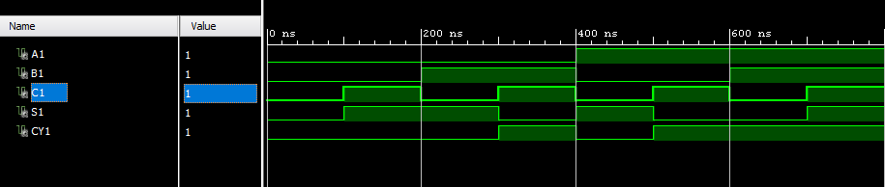

**HALF ADDER (STRUCTURAL MODEL)**

**VHD code**

entity HALF_ADDER_STR is

Port ( A : in STD_LOGIC;

B : in STD_LOGIC;

S : out STD_LOGIC;

C : out STD_LOGIC);

end HALF_ADDER_STR;

architecture STRUCTURAL of HALF_ADDER_STR is

component XOR_GATE is

Port ( A : in STD_LOGIC;

B : in STD_LOGIC;

C : out STD_LOGIC);

end component;

component AND_GATE is

Port ( A : in STD_LOGIC;

B : in STD_LOGIC;

C : out STD_LOGIC);

end component;

begin

L1: AND_GATE port map(A,B,C);

L2: XOR_GATE port map(A,B,S);

end STRUCTURAL;

**SCHEMEATIC DIAGRAM**

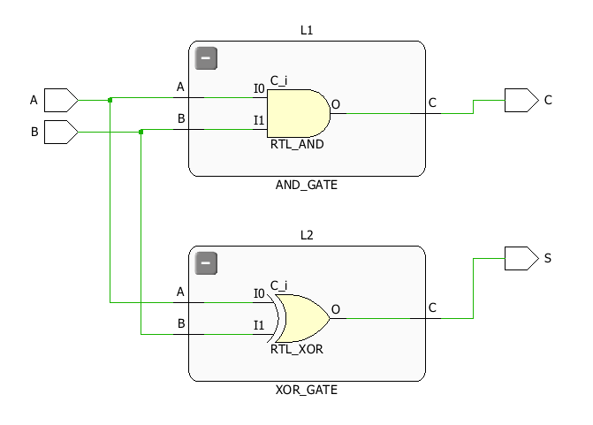

**TBW Code**

entity half_adder_str is

-- Port ( );

end half_adder_str;

architecture STRUCTURAL of half_adder_str is

component HALF_ADDER_STR is

Port( A: in STD_LOGIC;

B: in STD_LOGIC;

S: out STD_LOGIC;

C: out STD_LOGIC);

end component;

Signal A1:STD_LOGIC:='0';

Signal B1:STD_LOGIC:='0';

Signal S1:STD_LOGIC;

Signal C1:STD_LOGIC;

begin

uut: HALF_ADDER_STR Port Map(A=>A1,B=>B1,S=>S1,C=>C1);

Stim_proc:process

begin

wait for 100ns;

A1<='0';B1<='0';

wait for 100ns;

A1<='0';B1<='1';

wait for 100ns;

A1<='1';B1<='0';

wait for 100ns;

A1<='1';B1<='1';

wait;

end process;

end STRUCTURAL;

**TBW Waveform**

